**Final Report**

**Sub-Consultancy Agreement between VEI B.V. and FINISH INK**

**WWX-KE-WOP-INV 24-01-01 WOP KENYA, WFL FINISH MONDIAL 2 KE – WP3 N**

**June 2024 to February 2025**

|  |  |
| --- | --- |
| Counties under coverage | Nakuru & Kisumu |
| Report Focus | Sanitation. |
| Final report review and submission by | Pamela Bundi |
| Report prepared by | Ken Macharia. |
| Report submission | 22nd April 2025 |

1. **Introduction**

This report outlines the progress achieved in enhancing sustainable sanitation under the 2024 contract with VEI. FINISH INK has been engaged through contract WWX-KE-WOP-INV 24-01-01 WOP KENYA, WFL FINISH MONDIAL 2 KE – WP3 for the implementation of FINISH Mondial in Nakuru and Kisumu. This initiative aims to establish new safely managed and improved sanitation facilities in these regions, in partnership with four water utilities: NAWASCO, NARUWASCO, NAIVAWASS, and KIWASCO.

Targets for the two counties were as per the table below covering a total of 9 subcounties across the two counties.

|  |  |  |
| --- | --- | --- |
| **County** | **Sub-Counties** | **Target sanitation systems** |
| Nakuru | Nakuru East, Nakuru West, Molo, Gilgil, Naivasha, Rongai and Bahati | 8,970 |
| Kisumu | Kisumu East and Kisumu Central | 2,667 |

Under the 2024/2025 agreement, FINISH was to spearhead the construction and improvement of **11,734 sanitation systems** across Kisumu and Nakuru counties in jurisdictions covered by the four water utilities of NAWASSCO, NARUWASCO, NAIVAWASCO, and KIWASCO.

The objective of this was to impact the communities positively in terms of:

1. Improved health and reduce diarrheal diseases.
2. Enhanced safety and dignity for women and girls.
3. Promoting a circular economy through fecal sludge reuse.
4. Empowering communities economically via savings and access to credit.
5. Driving financial access for sanitation financing for households and sanitation entrepreneurs.

**Summary of Results**

|  |  |  |  |
| --- | --- | --- | --- |
| **Utility** | **Target** | **Actual** | **Achievement** |
| NAWASCO | 4,000 | 4,033 | 101% |
| NARUWASCO | 2,067 | 4,668 | 226% |
| NAIVAWASCO | 3,000 | 3,525 | 118% |
| KIWASCO | 2,667 | 3,822 | 143% |
| **Totals** | **11,637** | **16,048** | **138%** |

During the reporting period, the sanitation programme surpassed its construction and improvement targets across all participating utilities. A total of 16,048 sanitation systems were completed against a target of 11,637, achieving an overall performance of 138%.

Below is a month-on-month summary of the results:

|  |  |  |  |  |  |  |  |  |  |  |  |  |
| --- | --- | --- | --- | --- | --- | --- | --- | --- | --- | --- | --- | --- |
| **No of Toilet doors reported per water Utility per Month** | | | | | | | | | | | | |
| **Utility** | **NAWASSCO** | | | **NARUWASCO** | | | **NAIVAWASCO** | | | **KIWASCO** | |
| **Month** | Onsite | Offsite | Total | Onsite | Offsite | Total | Onsite | Offsite | Total | Onsite | Offsite |
| **June** | 340 | 107 | 447 | 292 | 0 | 292 | 227 | 0 | 227 | 399 | 0 |
| **July** | 538 | 144 | 682 | 379 | 0 | 379 | 296 | 67 | 363 | 396 | 0 |
| **August** | 521 | 6 | 527 | 147 | 0 | 147 | 297 | 9 | 306 | 497 | 1 |
| **September** | 685 | 125 | 810 | 476 | 0 | 476 | 521 | 0 | 521 | 418 | 63 |
| **October** | 473 | 70 | 543 | 531 | 0 | 531 | 400 | 50 | 450 | 417 | 94 |
| **November** | 374 | 117 | 491 | 530 | 0 | 530 | 490 | 20 | 510 | 522 | 33 |
| **December** | 180 | 10 | 190 | 657 | 0 | 657 | 379 | 20 | 399 | 196 | 0 |
| **January** | 152 | 41 | 193 | 1146 | 0 | 1146 | 418 | 30 | 448 | 440 | 30 |
| **February** | 124 | 15 | 139 | 510 | 0 | 510 | 261 | 40 | 301 | 316 | 0 |
| Totals | 3387 | 635 | 4022 | 4668 | 0 | 4668 | 3289 | 236 | 3525 | 3601 | 221 |

* NAWASCO slightly exceeded its target with 4,033 toilets constructed (101% achievement).
* NARUWASCO significantly outperformed expectations, delivering 4,668 toilets against a target of 2,067 (226%).
* NAIVAWASCO completed 3,525 toilets (118% of target), and
* KIWASCO achieved 143% of its target, constructing 3,822 sanitation units.

This performance reflects strong collaboration between the utilities, local artisans, communities, and financing partners, as per the Diamond model which is the principle guideline of how FINSIH operates and highlights the growing capacity and efficiency in delivering safely managed sanitation at scale.

Based on reported construction figures, the programme delivered a total of 16,048 sanitation systems across the four participating utilities between June 2024 and February 2025. This includes 13,945 onsite toilet doors and 1,092 offsite units. Using the project’s impact calculation model—where each onsite system benefits approximately 32 people (8 families × 4 members) and each offsite system benefits 4 people—the estimated total number of people reached is approximately 451,240. This includes 446,240 people served through onsite systems and 4,368 people through offsite systems. These results demonstrate significant reach and transformative public health impact across the target service areas.

During this period, the program expanded to 7 sub counties in Nakuru and 2 in Kisumu County. The project aimed at providing access to safe sanitation to a populous peri-urban poor through connection to conventional or condominium sewers and the rural population through construction of safely managed sanitation systems, it promoted a variety of sanitation systems including the ventilated improved single and double pit, the double and single leach pit and connection to septic tanks. The project focuses on and promotes safely managed sanitation systems.

**Beneficiary Reach and Impact**

From June 2024 to February 2025, the sanitation programme reached an estimated 481,724 individuals across Nakuru and Kisumu counties through the construction and improvement of 14,945 onsite and 1,092 offsite sanitation systems. This impact is based on the programme’s beneficiary calculation model, which estimates that each onsite system serves 8 families of 4 members each (32 people), while each offsite system serves 4 individuals.

Nakuru County contributed the highest share, with 11,344 onsite and 871 offsite systems, while Kisumu delivered 3,601 onsite and 221 offsite systems. The most significant monthly reach was recorded in January 2025, benefiting 69,276 people, followed by September 2024 with 67,700 beneficiaries.

|  |  |  |  |  |  |  |  |  |  |
| --- | --- | --- | --- | --- | --- | --- | --- | --- | --- |
| **County** | **Nakuru** | | **Kisumu** | | **Grand Total** | | **Beneficiaries** | | **Total Beneficiaries** |
| **Month** | **Onsite** | **Offsite** | **Onsite** | **Offsite** | **Onsite** | **Offsite** | **Onsite** | **Offsite** |
| **June** | 859 | 107 | 399 | 0 | 1258 | 107 | 40,256 | 428 | **40,684** |
| **July** | 1213 | 211 | 396 | 0 | 1609 | 211 | 51,488 | 844 | **52,332** |
| **August** | 965 | 15 | 497 | 1 | 1462 | 16 | 46,784 | 60 | **46,844** |
| **September** | 1682 | 125 | 418 | 63 | 2100 | 188 | 67,200 | 500 | **67,700** |
| **October** | 1404 | 120 | 417 | 94 | 1821 | 214 | 58,272 | 480 | **58,752** |
| **November** | 1394 | 137 | 522 | 33 | 1916 | 170 | 61,312 | 548 | **61,860** |
| **December** | 1216 | 30 | 196 | 0 | 1412 | 30 | 45,184 | 120 | **45,304** |
| **January** | 1716 | 71 | 440 | 30 | 2156 | 101 | 68,992 | 284 | **69,276** |
| **February** | 895 | 55 | 316 | 0 | 1211 | 55 | 38,752 | 220 | **38,972** |
| **Totals** | **11344** | **871** | **3601** | **221** | **14945** | **1092** | **478,240** | **3,484** | **481,724** |

1. **Activities and Deliverables**

Activities and deliverables for the period were clustered under 5 thematic areas these being: (1) government engagement, (2) Sanitation marketing/Demand creation (community engagement), (3) supply side development (sanitation business development and technical training), (4) financial inclusions and (5) Communication, Monitoring, evaluation and learning.

**2.1 Government Engagement**

**Project Implementation/ Planning/Review Meeting**

The government engagement component was broad and encompassed different activities:

* County project management team engagements i.e. High-level engagement among key stakeholders (project Introduction and update)
* County WASH Forums
* Review of low-income consumer investment plan/ pro poor strategic plan
* Capacity building of PHOS on market-based sanitation with a focus on safely managed sanitation
* Support and participation in County led sanitation campaigns, sanitation commemoration days for advocacy and/or awareness

Throughout the reporting period, FINISH INK maintained strong engagement with county governments and key stakeholders in both Nakuru and Kisumu counties to support the successful implementation and scaling of safely managed sanitation solutions. These high-level interactions were critical in fostering alignment, ownership, and policy support for the programme.

In Nakuru County, strategic engagements were held with the Department of Public Works, who played a key role in the review and approval of biodigester sanitation designs and supported the promotion of condominium sewer systems in targeted areas. Project inception meetings were conducted in two newly targeted sub-counties — Bahati (26th–31st August 2024) and another sub-county from 30th October to 1st November 2024 — to introduce the programme to local leadership and implementation teams. Additionally, project progress updates were presented to the County Health Management Team (CHMT) on 14th–15th November 2024, and a structured engagement with Public Health Officers (PHOs) across all implementation areas was conducted between 27th January and 2nd February 2025. The County Executive Committee (CEC) was also engaged to ensure strategic alignment and sustained political support. Throughout the period, monthly project updates were shared with the County Director of Public Health and WASH coordinators to ensure continuous coordination and transparency.

In Kisumu County, two high-level meetings were held with the County Executive Committee Member (CECM) for Health and the Director of Public Health, alongside representatives from FM Global, on 15th November and 2nd December 2024. These meetings served to brief top leadership on project progress, where the county expressed strong appreciation and affirmed its continued support. FINISH INK also participated in a stakeholder forum in Kisumu Central Sub- County on 20th December 2024, where 30 key stakeholders were sensitized on their role in strengthening WASH efforts. All participants committed to supporting sanitation initiatives within their respective mandates.

Further, a capacity-building workshop for 30 PHOs was conducted on 1st–2nd August 2024, focusing on Market-Based Sanitation (MBS) and the FINISH Mondial approach. PHOs were assigned specific targets per ward and took lead roles in driving sanitation outcomes. The programme also actively supported county-led advocacy during two major commemorative events — Global Handwashing Day (15th October) and World Toilet Day (19th November) — which collectively reached over **1,000 people**, including students at various educational levels. These platforms were instrumental in disseminating sanitation and hygiene messages and identifying potential clients for safely managed sanitation solutions.

Through these coordinated efforts, FINISH INK deepened its collaboration with county structures, promoted policy alignment, and enhanced stakeholder capacity — all contributing to the programme’s sustainable and

**2.2 Sanitation marketing/Demand creation (community engagement),**

**2.2.1 Training of sanitation marketers and CHPs on market-based sanitation**

As part of the programme’s demand creation strategy, FINISH INK focused on strengthening sanitation marketing by building the capacity of Community Health Promoters (CHPs) and freelance marketers, alongside ongoing technical support and system quality verification.

In Nakuru County, comprehensive training sessions were conducted in Nakuru North and Gilgil sub-counties between 7th–12th September 2024 and on 20th August 2024, respectively. A total of 51 sanitation marketers were trained — 29 in Nakuru North and 22 in Gilgil — with content focused on market-based sanitation principles, customer engagement, and effective promotion of safely managed sanitation. In addition, eight freelance marketers were trained during routine field visits, further enhancing grassroots outreach capacity. To reinforce knowledge and gather feedback, monthly review meetings were conducted with the trained marketers, enabling continuous learning and peer-to-peer exchange.

In Kisumu County, a dedicated training and refresher session targeting marketers from Kisumu Central sub-county was conducted on 3rd September 2024 and 22nd–23rd January 2025, respectively. A total of 30 participants, including CHPs and freelance marketers, were trained on the market-based sanitation approach, equipped with real-time reporting tools, and provided with branded marketing materials to support community outreach. Following the training, marketers actively created awareness at the community level and provided technical guidance to interested clients, contributing to increased sanitation uptake.

Review meeting with sanitation marketers in Nakuru East

**2.2.2 IEC Materials for demand creation**

During the reporting period, a range of Information, Education, and Communication (IEC) materials and branded visibility items were developed and produced to support outreach, stakeholder engagement, and programme visibility. These included overalls for artisans, T-shirts, caps, reflector jackets, flyers, additional flip books for sanitation marketers, posters, and toilet models.

The materials were distributed across Nakuru and Kisumu counties and served multiple purposes: enhancing public awareness of sanitation initiatives, reinforcing brand visibility, and recognizing outstanding contributions by stakeholders. Select items were also used as incentives to motivate and reward exemplary performance among artisans, marketers, and community mobilizers actively driving the programme’s success.

Some of the sample items are as below:

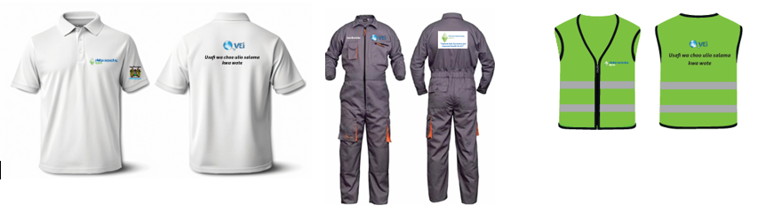

#### ****2.2.3 Technical Supervision and Quality Assurance****

To ensure consistency and reliability of reported sanitation systems, integrated support supervision and quality verification visits were conducted regularly across implementation sites. A total of eighteen visits took place between July 2024 and February 2025, including eight physical verifications each in Kisumu and Nakuru and one joint supervision with county officials in each of the two. During these visits, sanitation systems that were pending verification from desktop reviews underwent detailed quality checks. Identified gaps—ranging from construction inconsistencies to incomplete documentation—were addressed promptly, resulting in improved quality of reported toilets and a notable reduction in system rejections in the months that followed.

The sessions were also instrumental in highlighting key areas that the marketers should focus on as well as rewarding the outstanding marketers in the communities.

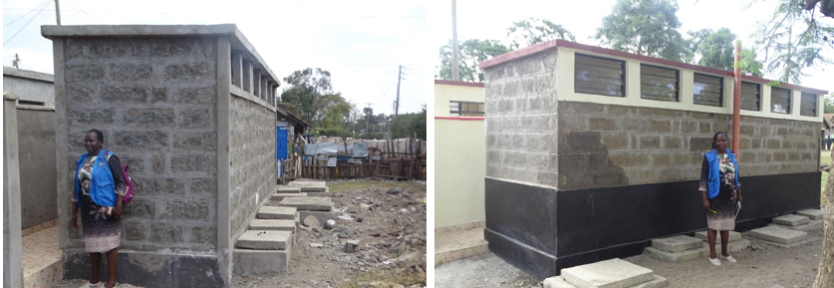

*Marketed and reported sanitation facility in Nakuru Town- railways*

**2.2.4 Incentives payable to the marketers per system constructed**

Over the reporting period, incentives were disbursed for a total of 16,037 sanitation systems verified and reported. The programme employed a two-tiered incentive mechanism designed to motivate and reward key actors involved in sanitation uptake and reporting.

This system recognizes the contributions of:

* Community Health Volunteers (CHVs), who serve as frontline sanitation marketers, and
* Public Health Officers (PHOs), who are responsible for verifying and reporting the constructed systems.

Under this structure, CHVs receive Ksh. 250 per verified system, while PHOs are allocated Ksh. 100 per system. Incentives are processed and paid on a monthly basis, following system verification.

In total, Ksh. 5,612,950 (approximately €46,774) was paid out in incentives during the reporting period. This approach has proven effective in sustaining momentum and ensuring accountability in sanitation delivery at the community level.

**2.3 Supply side development (Sanitation business development and technical trainings),**

**2.3.1 Business trainings**

As part of efforts to strengthen the sanitation value chain, the programme implemented targeted business development interventions aimed at enhancing the capacity of sanitation entrepreneurs in both Nakuru and Kisumu counties. These activities focused on building skills in financial management, bookkeeping, marketing, and business planning, complemented by ongoing mentorship and coaching.

In Nakuru, a comprehensive business training on bookkeeping and financial management was conducted from 22nd to 26th October 2024, engaging four entrepreneurial groups comprising 27 participants. The training aimed to improve financial literacy and equip entrepreneurs with practical tools for managing and growing their businesses.

To reinforce the skills acquired, routine follow-up and mentorship sessions were held monthly, with key sessions conducted on 16th–20th November, 14th December 2024, and 10th–18th January 2025. These engagements revealed positive progress, with businesses beginning to maintain financial records and demonstrating improved organizational practices.

|  |  |  |
| --- | --- | --- |
| **Key Entrepreneurial Groups in Nakuru** | | |
| **Group** | **#** | **Activities** |
| Shabab Mavuno Cleaning Services | 15 | The key activities include; affordable garbage collection, received training on business management and financial planning |
| Rhonda Community Health Promoters Self-Help | 15 | community health promotion initiatives, trained on utilizing a transactional ledger for effective savings management. |
| Rhonda Artisans Self-Help Group | 15 | Specializing in exterior construction design and sales, received training on business expansion and marketing strategies |
| Nyalunya CU | 12 | This is a group of community health promoters normally mandated to sensitize the community on health matters, besides this they sell toilet products like sato products and soap. They group was trained on the transactional ledger- a transparent saving mechanism and general business management. |
| Okok CU (A CHP group also in sato product sales) | 13 | The group was trained on book keeping, business plan development, financial management and marketing. All the groups received mentorship and coaching sessions that enabled them to pick and understand their business better after the training. |

In Kisumu, a high-level business training and coaching session was held on 16th January 2025, specifically targeting sanitation-related entrepreneurs including pit emptiers, waste collectors, water vendors, soap makers, and SATO product stockists. The session, facilitated by FINISH Mondial Kenya (FMK), covered essential business topics such as bookkeeping, financial planning, marketing, and business plan development.

In addition, follow-up visits were conducted on 19th–20th September 2024, during which 10 entrepreneurs were engaged based on their individual action plans. The follow-ups provided tailored support on areas such as record keeping, marketing strategies, and financial management. Entrepreneurs supported under this initiative included pit-emptiers, garbage collectors, entrepreneurial artisans, and SATO toilet product distributors.

**Table showing Financial Institution Engagement**

|  |  |  |  |  |
| --- | --- | --- | --- | --- |
| **County** | **Financial Institution (FI)** | **Status of Engagement** | **Outcome** | **Way forward** |
| Kisumu | Elphrods Services | Continuous | Continuous engagement has been carried to conduct community group meetings through the Sub-County offices in Seme and Nyakach  The groups visited include Agoro East, Magunga, Katito Urban, Gem Nam, Gem Rae, Rarieda, and Lisana. | Strengthen collaboration with Elphrods Services to finalize loan facilitation mechanisms and conduct follow-up meetings with the targeted groups to support loan uptake and expand access to sanitation financing. |
| Nakuru | Bimas  Vision SACCO and Tower SACCO | Continuous  Mapped | The partnership is ongoing with the model based on results-based incentives  Vision SACCO and Tower SACCO in Gilgil Sub-County have been mapped and initial appointments scheduled. | Strengthening the partnership to scale up results  Interested in sanitation financing. Support to be provided for pipelines for loans in water and sanitation. |

**2.3.2 Artisanal trainings**

During the period, FINISH supported hands-on artisan training sessions across Kisumu and Nakuru counties, combining skills development with the construction of improved sanitation systems. In Kisumu County, 50 artisans were trained across two sessions. The first, held at Obinju Primary School in August, led to the construction of a 4-door VISP unit with a changing room and disability-inclusive features, benefiting 650 girls. The second session in October at MP Shah Primary School resulted in a 12-door flush toilet block connected to the sewer, serving approximately 1,800 girls.

In Nakuru County, 54 artisans were trained in Gilgil and Bahati sub-counties. These sessions supported the construction of various household sanitation systems, including leach pits, VIDPs, and VISPs, directly benefiting 33 household members. This approach not only improved local sanitation infrastructure but also built technical capacity within communities, ensuring long-term maintenance and replication of safe sanitation solutions. This is intended to ensure that quality standards and the principles of safely managed sanitation are upheld in the market, as well as to ensure that they remain up to date with the efficiency and cost-effectiveness of sanitation infrastructure development. Other soft issues were covered during the training which included considerations on gender sensitivity sand disability inclusiveness in toilet constructions. The training also eemphasized the importance of public health and environmental protection such as ensuring ground water is not contaminated. In addition to the 104 formally trained, an additional 22 artisans received on-the-job training.

Extensive field visits were conducted to assess the practical application of previously imparted training. These visits focused on providing on-the-job training, addressing specific challenges faced by artisans during construction, and ensuring adherence to best practices including safety and compliance, prioritizing occupational health and safety, equipping the artisans with knowledge on proper safety protocols to reduce workplace hazards during construction activities.

|  |  |  |  |  |
| --- | --- | --- | --- | --- |
| **County** | **Date** | **#Artisans trained** | **Location of training & Sanitation systems built in the course of the training** | **Population to be served** |
| Kisumu. | 19th- 25th Aug 2024 | 25 | Kisumu Central- Obinju Pri.  4- door VISP with changing room and a PWD provision | 650 girls |
| Kisumu | 10th- 16th Oct 2024 | 25 | MM Shah Primary (Kisumu Central)  12 door Flush toilets connected to sewer | 1800 girls |
| Nakuru | 2nd-13th Sep 2024 | 27 | Bahati  2 door VISP and 2 door VIDP | Household -  19 members |
| Nakuru | 23rd - 30th July 2024 | 27 | Gilgil  Leach pit and VIDP | Household -  14 members |

The training target for the year was 30 artisans; however, due to gaps in the availability of skilled artisans in the newly engaged sub-counties—and the opportunities identified to drive results—a total of 104 artisans were trained, achieving **288% of the target**. This significant scale-up was made possible through careful cost management and a strong focus on training efficiency.

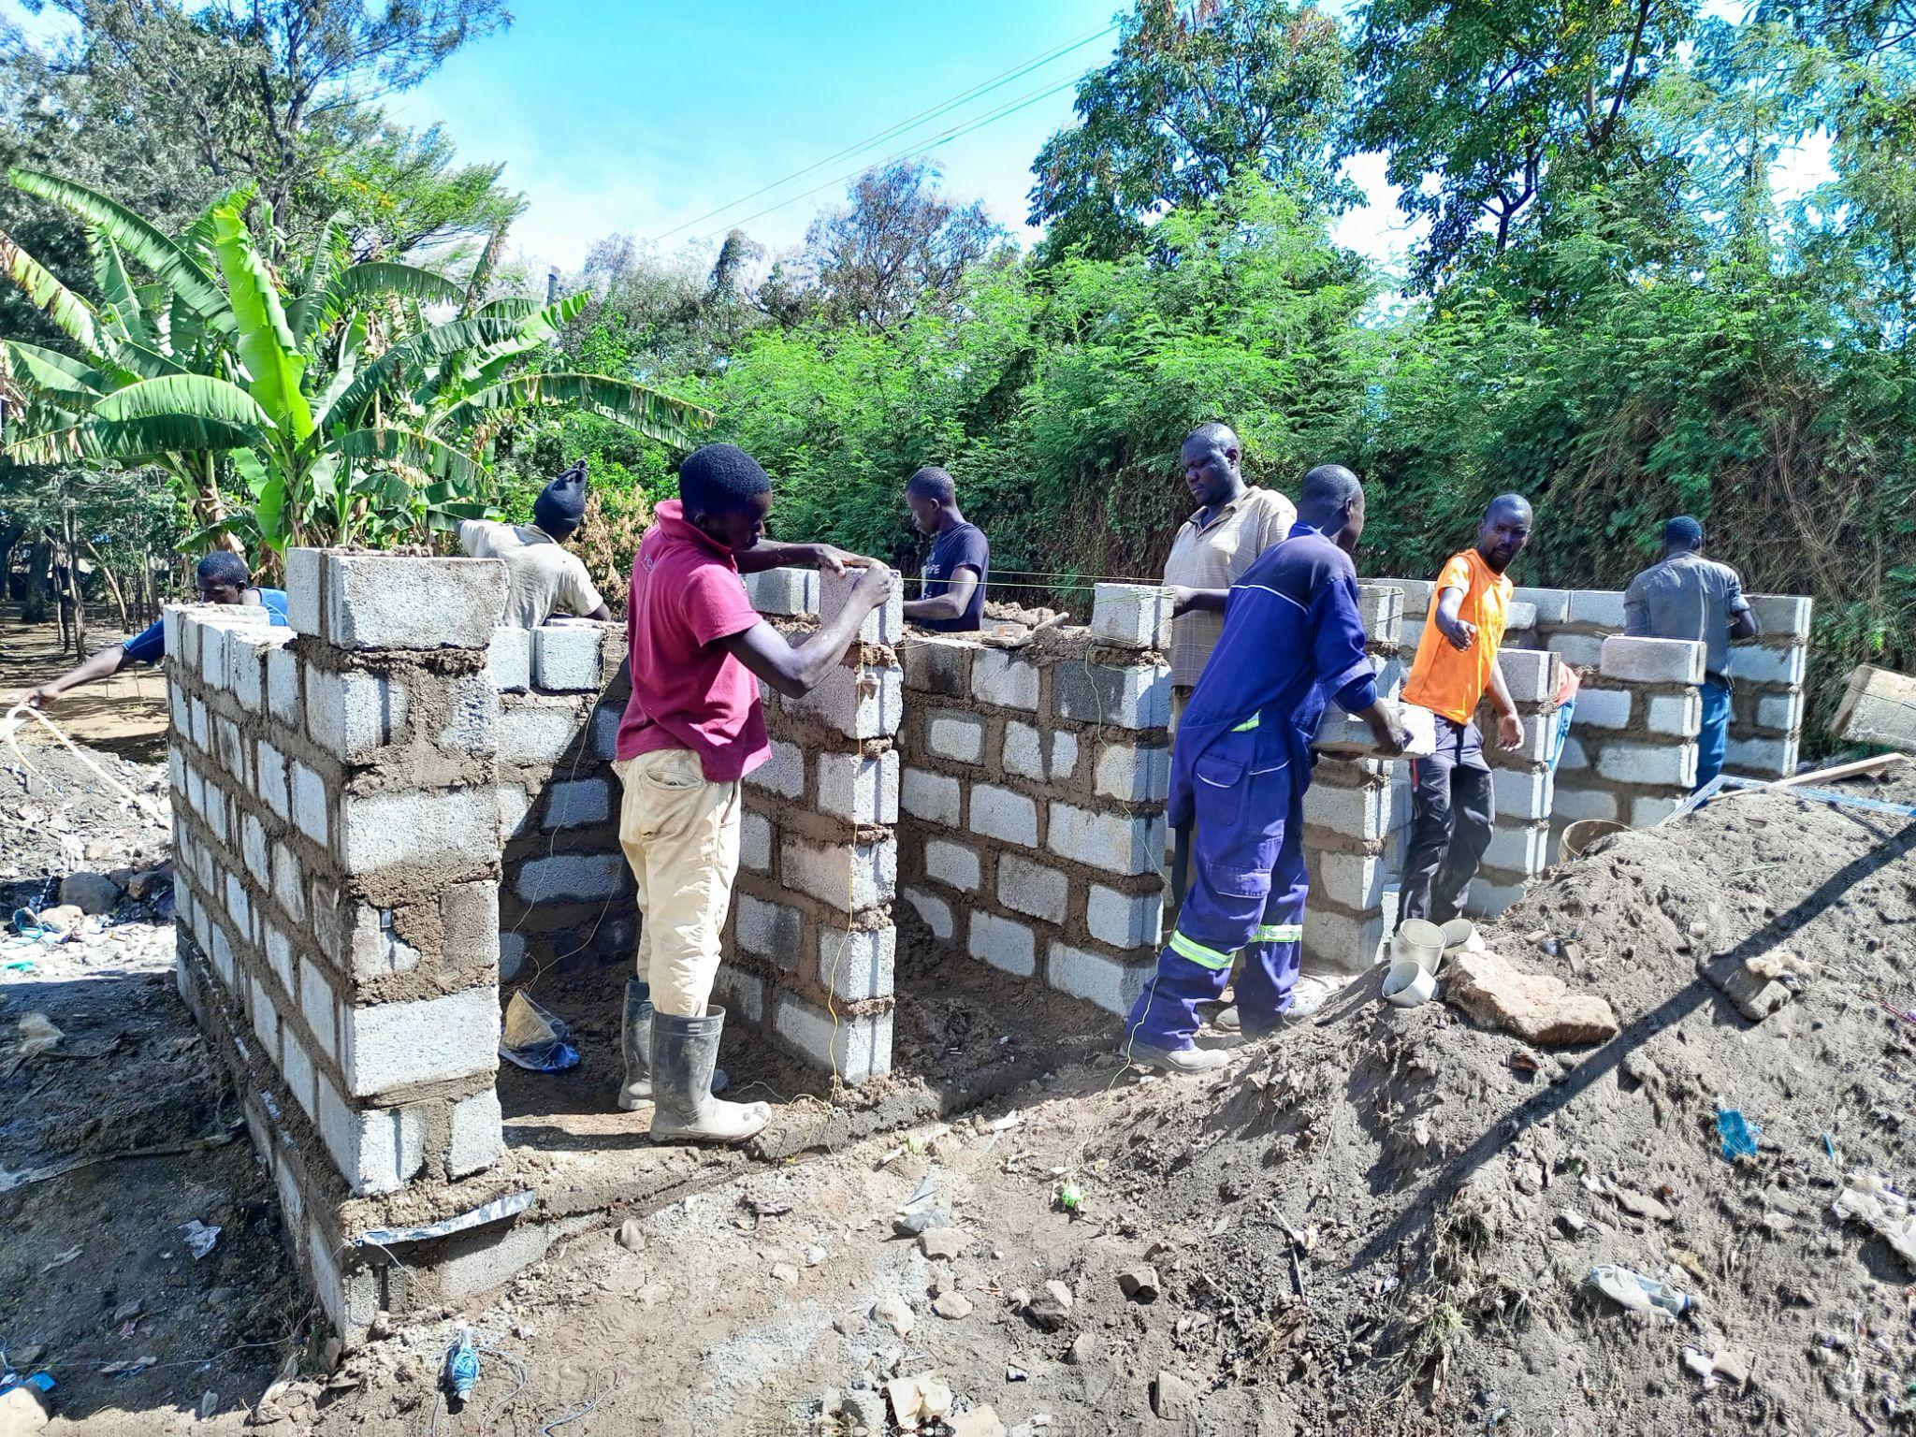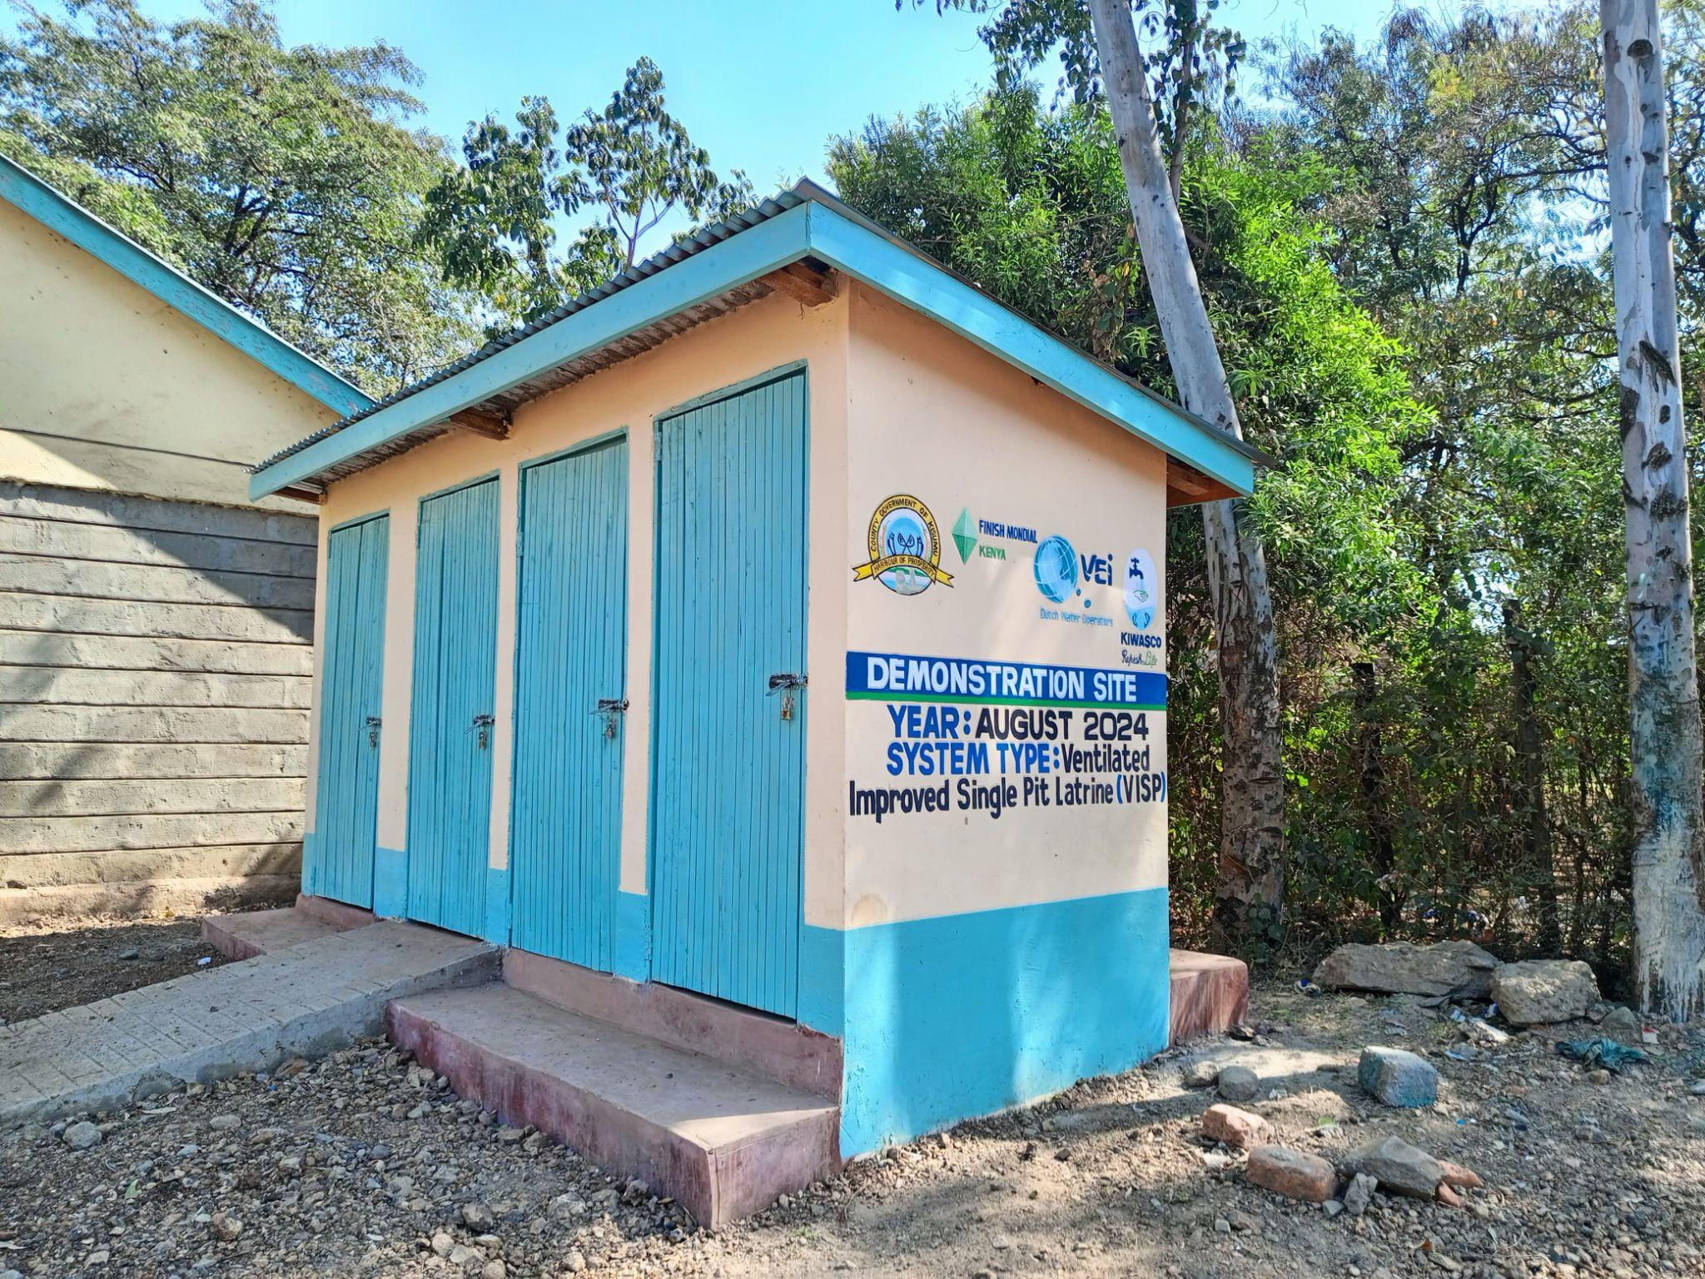

*Training of artisans in Kisumu County*

**2.4 Financial Institutions Engagements and Strengthening**

During the reporting period, the project implemented a multi-faceted strategy to strengthen partnerships with financial institutions (FIs) in Nakuru and Kisumu counties, with the goal of expanding access to sanitation financing for households and small-scale sanitation entrepreneurs. This strategy included capacity building of the partner FI staff, support in client linkages by linking the clients by sanitation marketers to the FI loans officers, loan performance monitoring, results-based financing incentives, development of promotional materials, and support for digital financial tools.

In Nakuru County, BIMAS remained the main partner at the onset but later in the 7th months, engagement of Tower SACCO was initiated and with that a capacity-building session was held on 29th January 2025 with branch managers and their teams from Nakuru and Gilgil sub-counties. The session introduced them to the programme’s sanitation financing approach and the Results-Based Financing (RBF) model. For Kisumu, the FI partnership focus was with Elphrods Services who had been in the collaboration since 2023 and in 2024 the introduction of the Results Based Incentive model was introduced as a motivation for them.

In Nakuru, the programme facilitated over 4,000 sanitation-related loans through participating institutions. In Kisumu, Elphrods Services, a partner FI, supported approximately 800 loans covering toilet construction and upgrades, water and sewer connections, and pit emptying. These incentives played a critical role in encouraging financial partners to actively promote and grow their sanitation loan portfolios.

Credit access for sanitation-related businesses was also enhanced through initiating a pilot of credit guarantees for hardware’s to support by giving products on credit and instalment payments to households willing to upgrade their sanitation facilities. In Gilgil, Nakuru, a hardware store was introduced to the model and showed interest in the credit guarantee mechanism, particularly for sanitation-linked products. In Kisumu, Adera Hardware was formally engaged and onboarded through a signed Memorandum of Understanding on 3rd December 2024, marking a significant step in strengthening the sanitation supply chain.

Monthly follow-ups and quarterly review meetings were integral in sustaining momentum with FI partners. In Nakuru, loan officers from BIMAS Microfinance, particularly in Nakuru West and East sub-counties, remained actively involved in the programme. Project teams routinely connected them with potential clients, especially in Rhonda sub-county, where sanitation loans were in high demand. In Kisumu, a joint review and refresher session was held on 31st January 2025, bringing together 30 participants, including FI representatives and county officials. The session focused on evaluating product performance, identifying areas for scale-up, and reaffirming cross-sector collaboration.

A key innovation introduced during the period was the Transactional Ledger App, aimed at enhancing digital financial inclusion for sanitation groups. In Nakuru, Manyani Garbage Collectors and Eco Green Youth Group began saving through the app, with Eco Green and City-Wide groups continuing to show strong adoption. In Kisumu, follow-up support was provided to Okok Community Unit and Nyalunya Community Unit in September and December 2024, both of which successfully began using the platform for savings tracking and financial management.

**2.5 Communication, Monitoring, evaluation and learning.**

**2.5.1 Monitoring, evaluation and learning**

Throughout the implementation period, the project organized quarterly review meetings with key field-level actors—Public Health Officers (PHOs), water utility focal persons, VEI, sanitation marketers, artisans, to monitor progress, reflect on experiences, and collaboratively chart the way forward. These sessions served as essential platforms for cross-learning, problem-solving, and alignment across all implementing partners. Government representatives also actively participated, reinforcing public sector ownership and providing additional support to ensure an enabling environment for effective delivery.

The quarterly meetings played a pivotal role in advancing project outcomes. They enabled the teams to track progress against set targets, identify and resolve challenges early, and make evidence-based decisions using shared data. Additionally, these sessions fostered accountability, encouraged peer learning, and enhanced coordination among stakeholders, thereby strengthening overall programme performance.

Below is a summary of key discussions and strategies that worked well and enabled the achievements.

|  |  |  |
| --- | --- | --- |
| **Discussion Highlights** | **Effective Strategies and Way Forward** | |
| - Review of project progress at the time of the meeting | | - Emphasis on teamwork and collaboration among stakeholders |
| - Experience sharing: what worked well, challenges, and solutions | | - Strengthened linkages across the Diamond Model (community, FIs, gov’t) |
| - Understanding sanitation quality standards and reporting criteria | | - Improved marketing approaches tailored to reach targets more effectively |
| - Refresher on the real-time reporting tool and verification steps | |  |
| - Review of quarterly targets and strategies for achieving them | |  |
| - Agreement on action points and next steps | |  |

Some of the key highlights and lessons that emerged from these review meetings were the successes in strategies taken to increase the uptake of sanitation which included:

1. Targeted Landlord Marketing: Targeted marketing efforts were directed towards landlords in areas with newly installed sewer lines, encouraging them to connect to the sewer networks provided by water utilities in Nakuru and Kisumu Counties.
2. Collaborative Community Sensitization sessions where the project team, comprising public health, community health promoters and public works officials, conducted community sensitization campaigns on the need for safely managed sanitation systems.
3. Participation In public forums organized by both county and national governments, including the Agricultural Show Ground of Kenya and community barazas and using these platforms to share sanitation options and their benefits to participants.

**In terms of monitoring and control, the project had robust systems in place which included:**

1. Quality Control and Evaluation: Meticulous evaluations were carried out on newly constructed toilet facilities to guarantee compliance with established standards. This included detailed inspections of connections to newly installed condominium sewer systems, ensuring proper functionality and long-term sustainability.
2. Standardization and Tracking of artisans : A comprehensive tracking exercise was initiated in July 2024 to identify and register all active artisans across both Nakuru and Kisumu Counties. This exercise aimed to create a centralized database, facilitating targeted training and capacity-building initiatives. A consolidated list has been made to be able to follow up with artisans.
3. Use of **GIS Map showing sanitation densities in Nakuru and Kisumu County and correlating the data with the reported systems by marketers.**

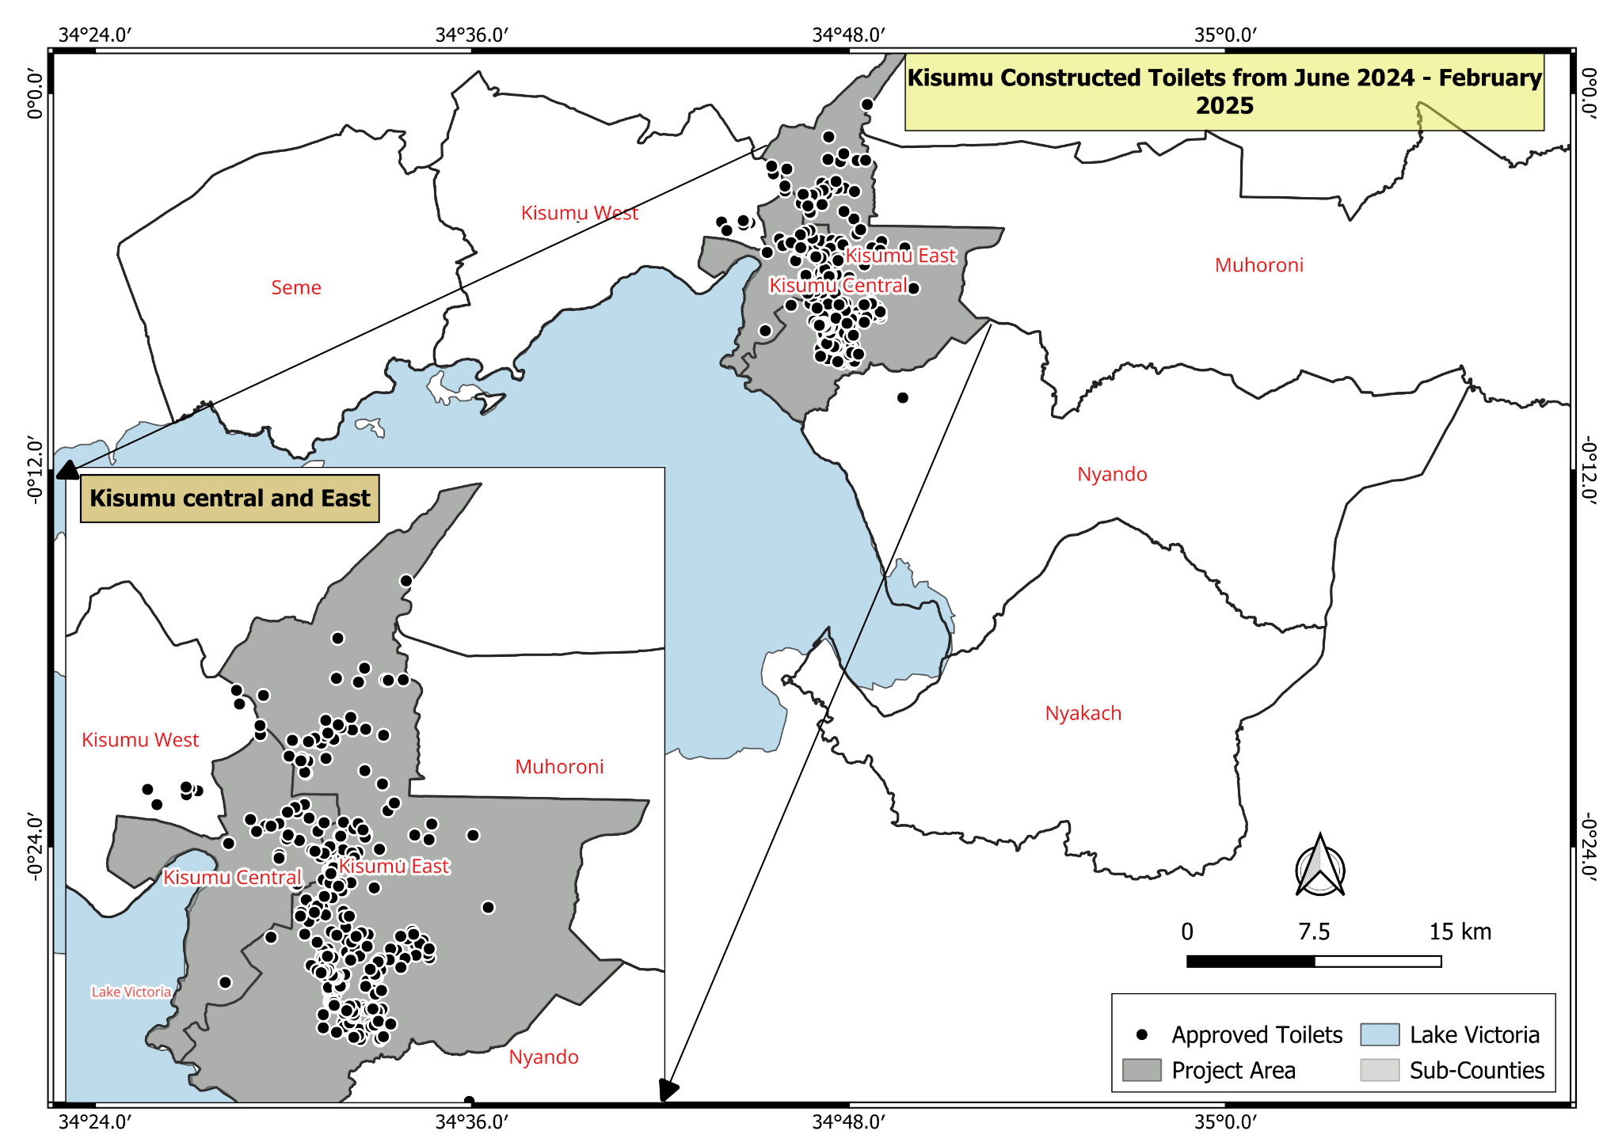

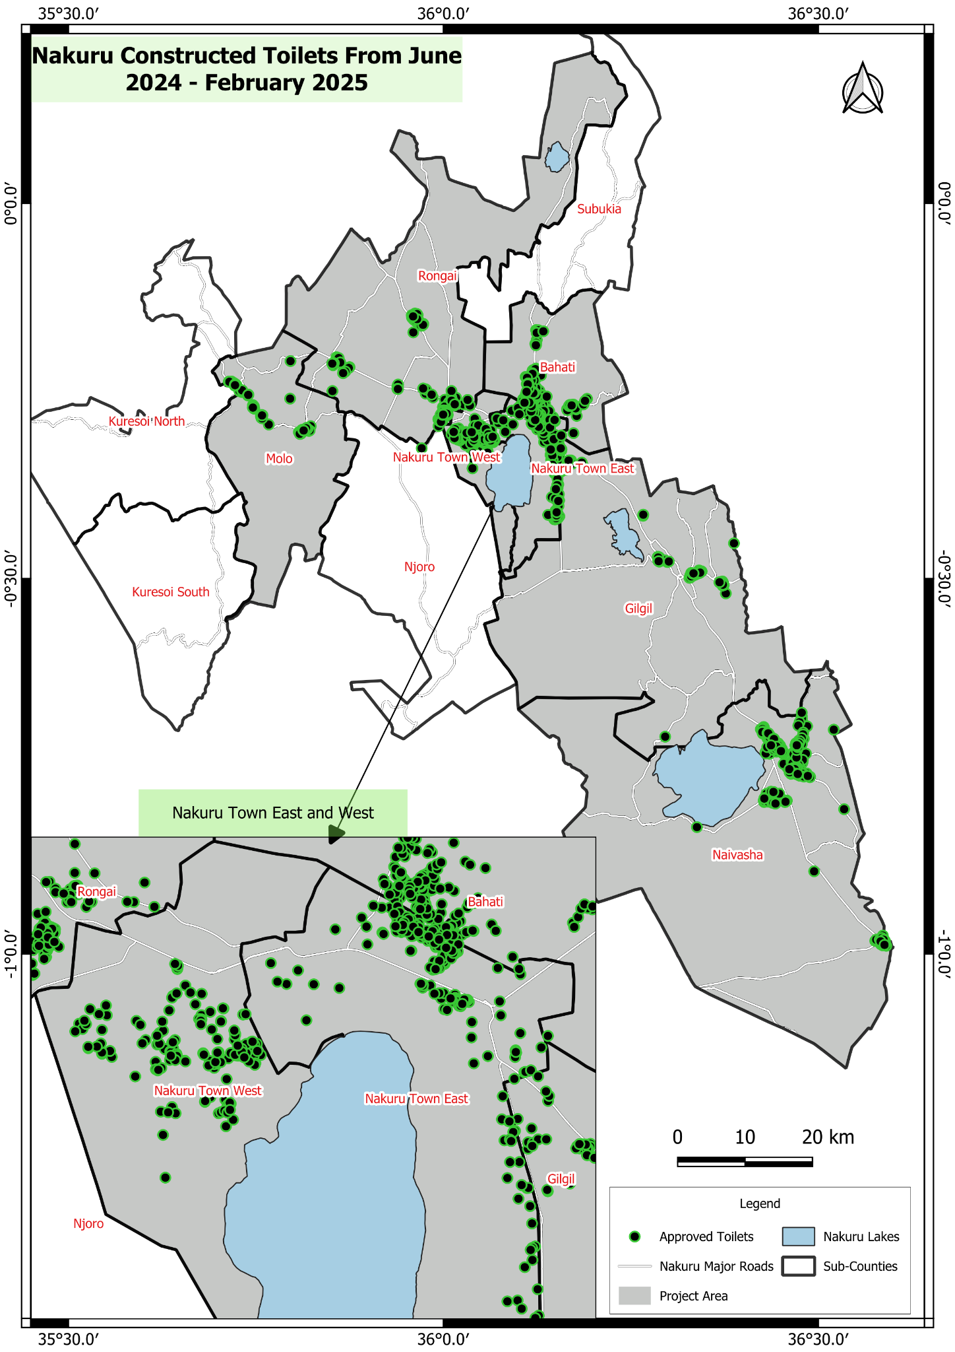

**2.5.2 Communication and outreach**

**Highlights in the Year**

***WWX Sponge City Concept Development and Launch***

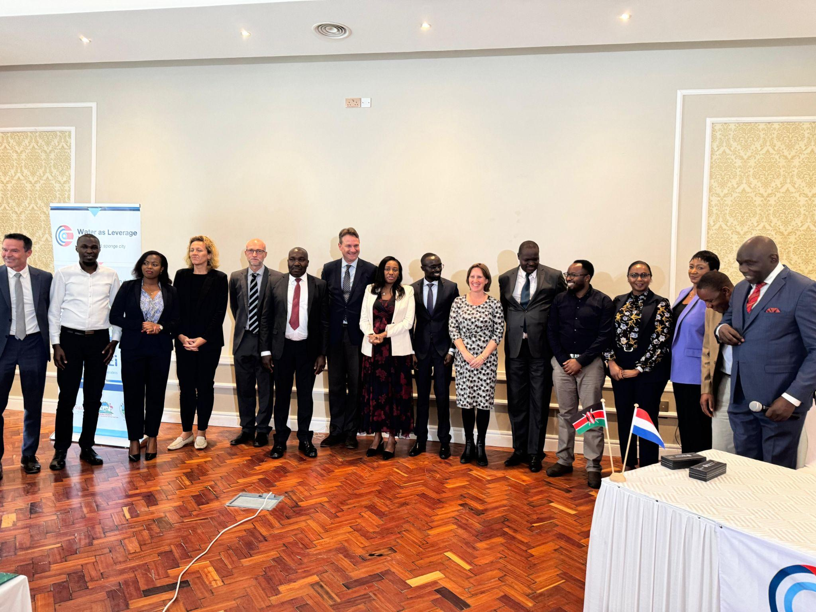The Sponge city project planning, led by Water as Leverage, was participated in by FINISH INK. This project, designed to address challenges related to water management and climate change adaptation, drew participation from a range of stakeholders. These stakeholders include government entities, water utilities, local communities, and development partners. Planning has begun on protecting the main water catchment areas in Kabatini, Nakuru North sub-county. These areas, which contain oil fields that supply 80% of Nakuru's urban water, are being targeted for aquifer recharge efforts.

*Partners in the WWX Sponge City Development and Launch*

***Global Hand washing Day***

The global celebration took place on October 15th, and Kisumu successfully marked the day, reaching approximately 300 community members with messages on hygiene and good sanitation practices. Additionally, 150 school pupils were sensitized on proper hand washing procedures and key times to wash hands. Continuous sensitization efforts will continue to promote clean sanitation and hygiene among both community members and schools.

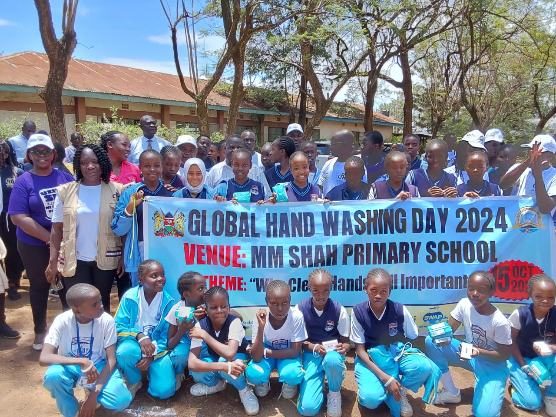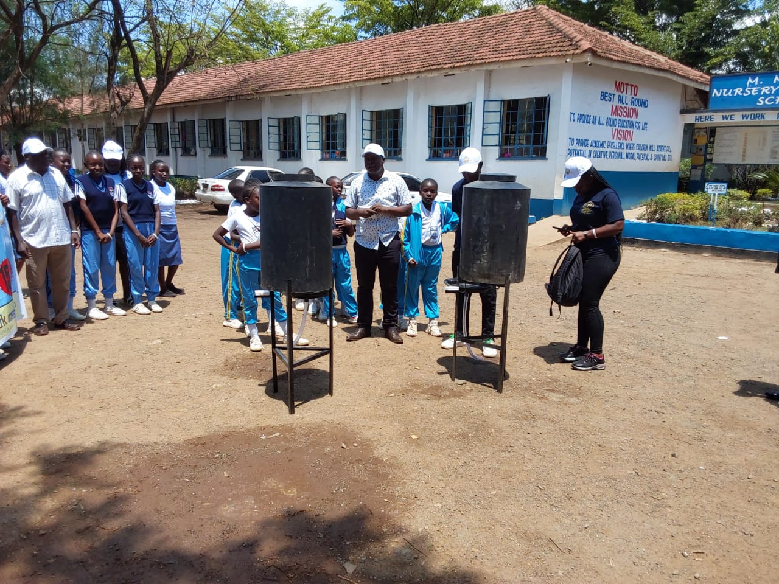

*Global handwashing day*

***Rurii School's Sustainable Sanitation Triumph***

In a collaborative effort, FINISH INK, alongside WaterWorX, USAID Tuungane Jamii, Mobile Alert Toilets, Systema Bio, the Public Health Department, and NAWASSCO, commissioned 52 new sanitation facilities at Rurii Comprehensive School. This project replaced contaminating pit latrines with modern, biogas-linked toilets, providing clean cooking gas for the school kitchen and protecting Nakuru City's aquifers, which supply over 70% of its residents' water. The new system significantly reduces groundwater contamination risks, safeguarding the city's water supply. FINISH INK played a crucial role in this project, overseeing the construction through a lead artisan they had trained. They were also responsible for processing the approved sanitation designs from the Public Works Department, ensuring adherence to regulatory standards. Furthermore, the site served as a valuable training ground for all artisans engaged in the construction, enhancing local capacity in sustainable sanitation practices.

The facilities were designed with social inclusiveness in mind, featuring changing rooms, wheelchair ramps, and a dedicated PWD-accessible room. This comprehensive approach ensured that all students, regardless of ability, have dignified and accessible sanitation. The integration of the biogas plant demonstrates sustainable resource management, turning waste into energy. The project's success underscores the importance of multi-stakeholder partnerships in delivering impactful sanitation solutions that prioritize environmental protection and community well-being.

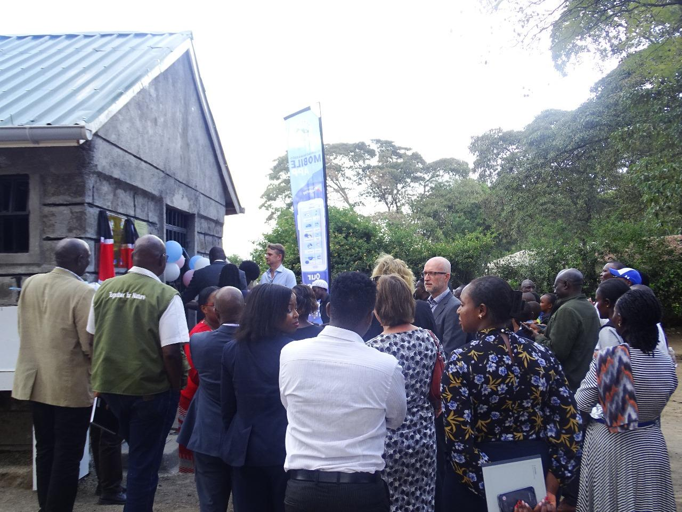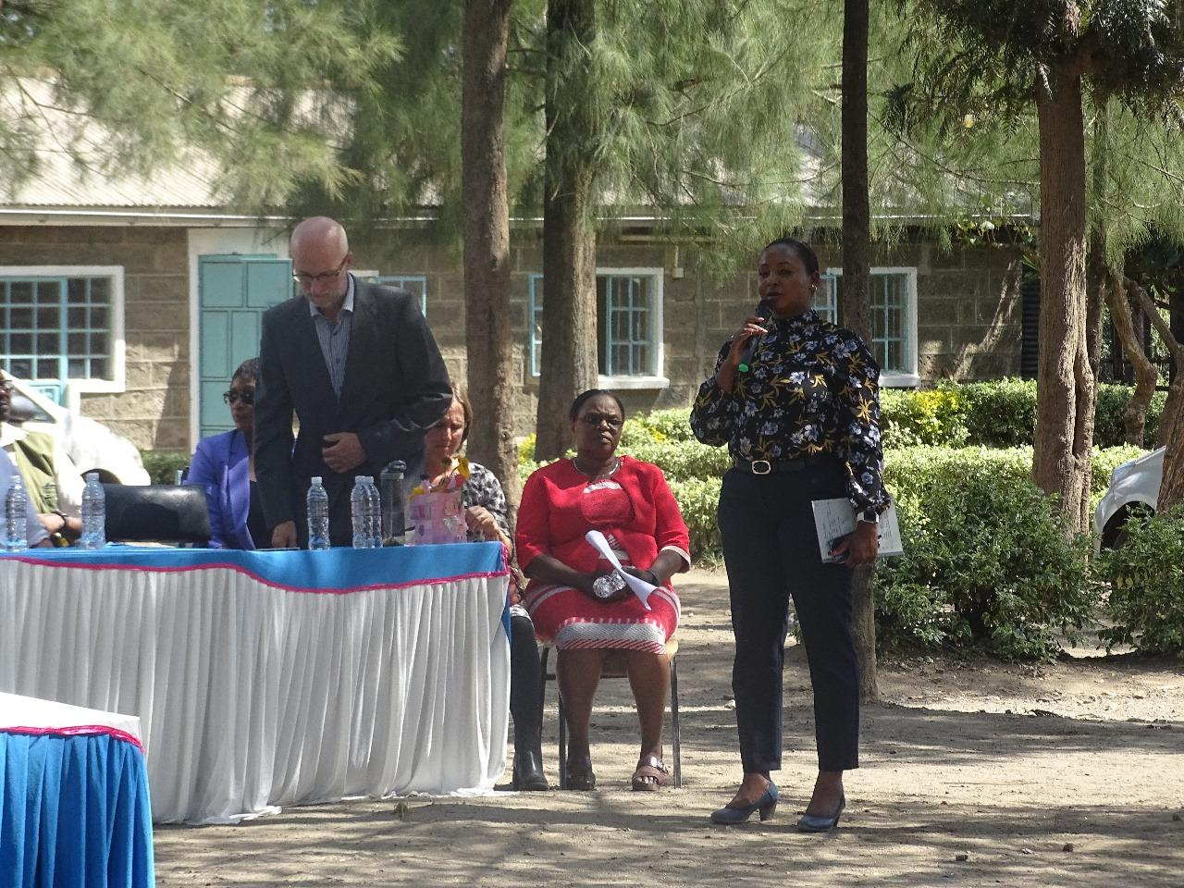

*Commissioning of the Rurii school toilets*

## *Innovate 4 WASH*

The event took place from October 16th to 18th at The Vic Hotel in Kisumu. It provided a platform to network, exchange ideas on WASH (Water, Sanitation, and Hygiene), and showcase toilet technologies. The conference significantly increased the visibility of the project's activities, products, and services. Potential clients for improved toilet systems were identified, and targeted follow up sessions conducted to engage them further. As a result seven households from the target individuals committed to upgrading their sanitation facilities. This led to significant improvement in their sanitation status, ultimately contributing to an increased number of people with access to safely managed sanitation- contributing to the SDG 6.

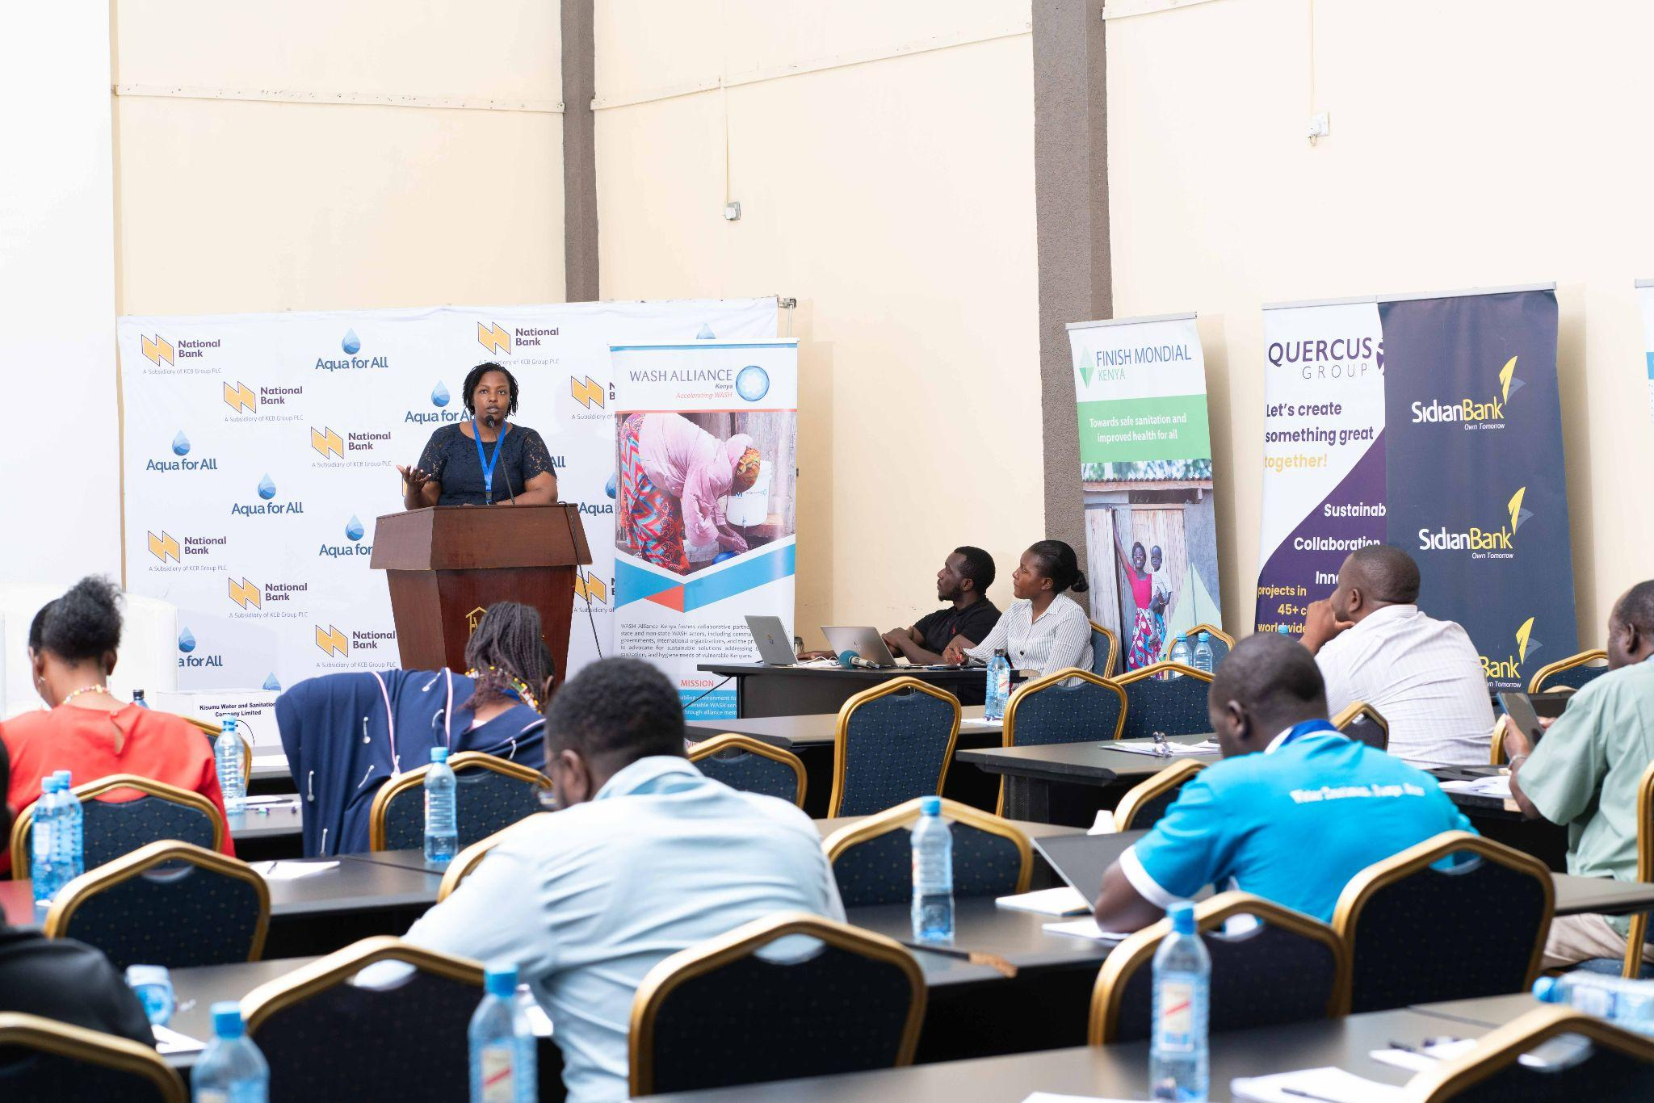

*Charlotte presenting about FINISH Mondial to the Conference attendees*

*GIZ Field Visit*

On October 18th, in Kisumu County, activities focused on enhancing fecal waste management and exploring biogas recovery systems as part of climate change mitigation efforts. A targeted institution involved in the school sanitation program was visited, where advice was provided on the most suitable biogas site and technology for the institution. Follow-up actions were planned with the team to ensure smooth coordination and successful implementation of the school sanitation project.

## *World Toilet Day*

The World Toilet Day was marked under the theme: "Toilets: A Place for Peace." The event reached 2,000 people with messages on the importance of constructing safe toilets that promote peace, security, dignity, and inclusivity by being gender-sensitive and disability-friendly.

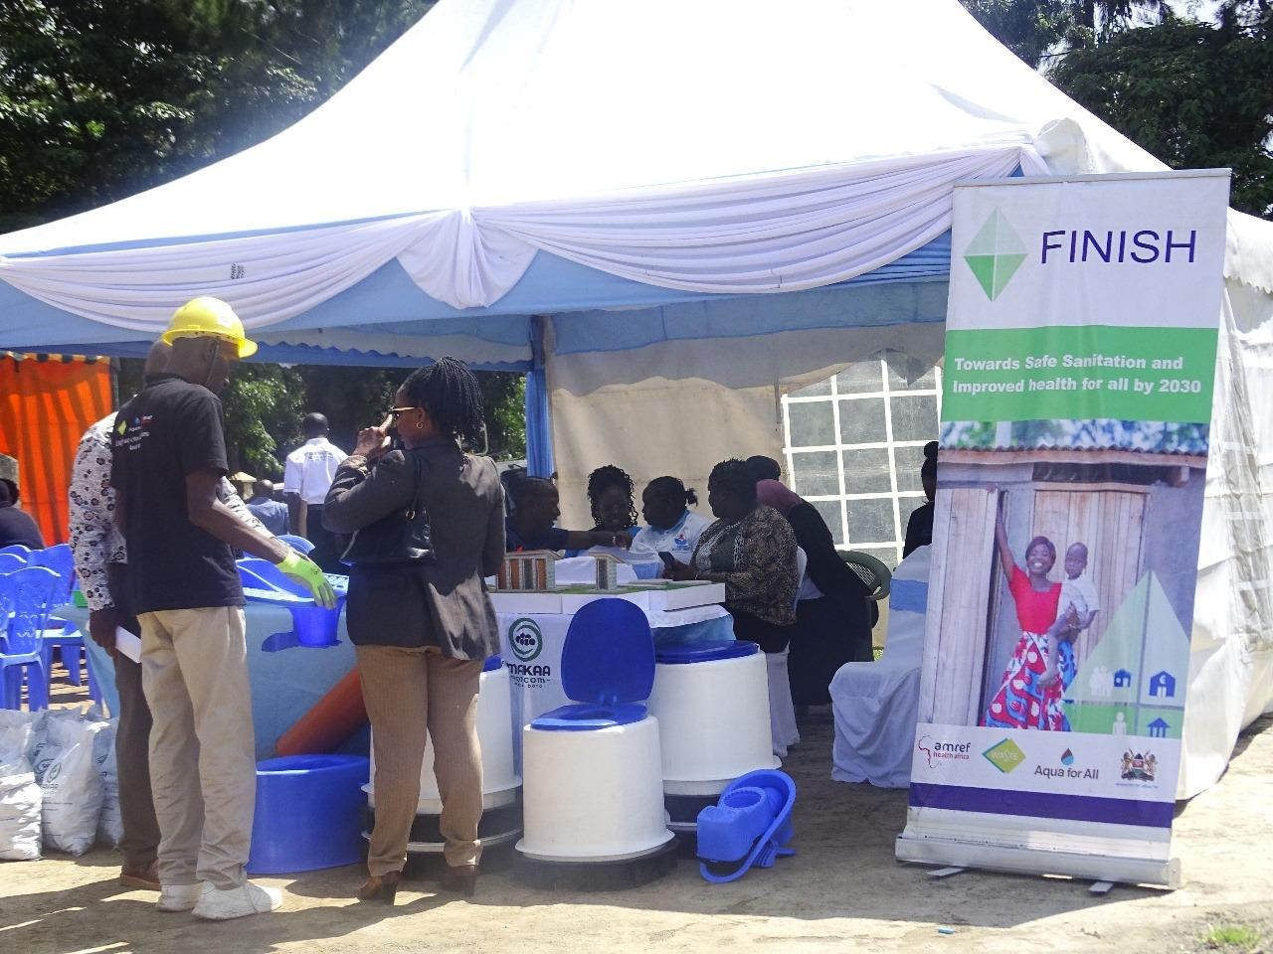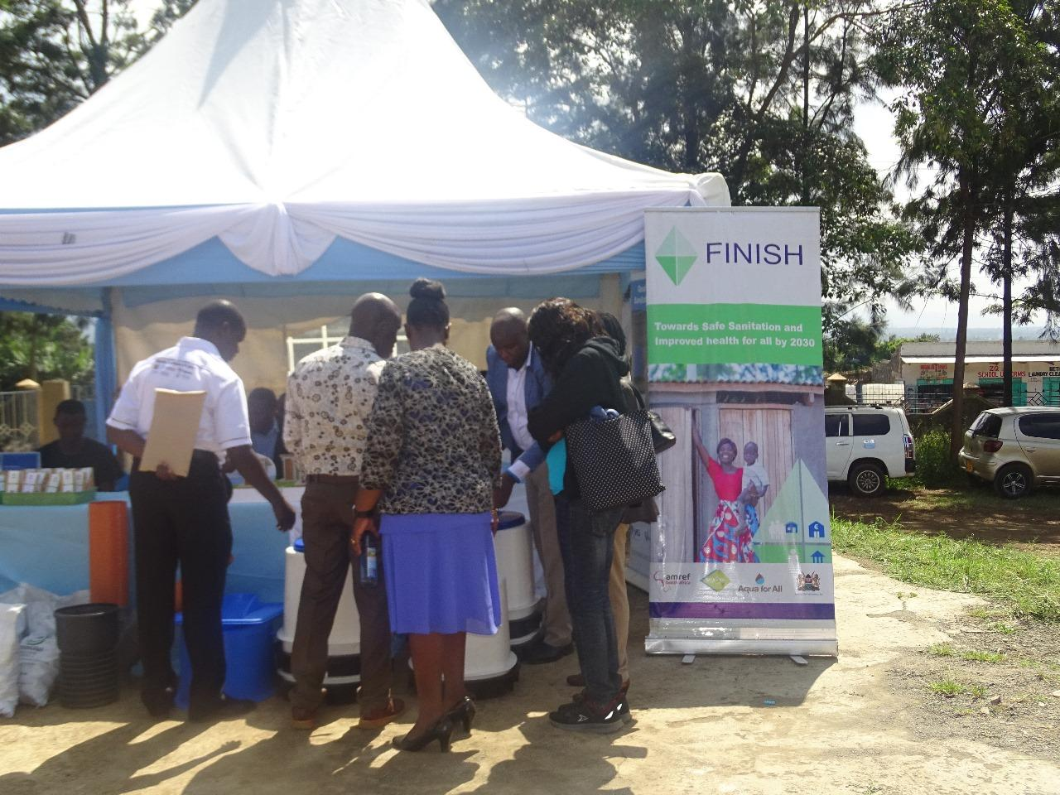

*World Toilet Day in Bahati, Nakuru County*

1. **Challenges and Lessons learnt**

While demonstrating significant progress, a number of key challenges and valuable lessons were observed. A recurring obstacle was maintaining consistent quality control across all sanitation systems that were reported. The geographical spread of the initiative, encompassing diverse communities, made uniform implementation difficult. Despite rigorous training, ensuring that all artisans adhered to the established standards required constant monitoring and logistical ingenuity. Reaching every artisan, particularly those in remote areas, presented its own set of logistical hurdles, demanding creative solutions and resourcefulness.

*Figure SEQ Figure \* ARABIC 2 indicates a capacitation process of a new marketer in Naivasha Sub County.*

*Figure SEQ Figure \* ARABIC 1 The figure indicates the physical verification process of the reported facilities in October*

On the entrepreneurial front, while the initiative successfully fostered business acumen and financial literacy, sustaining the momentum of these nascent enterprises proved a persistent challenge. Even with meticulously maintained records and formal registration, access to substantial financial loans remained a significant barrier, hindering the potential for expansion and further growth. This highlighted the need for more robust linkages with financial institutions and the development of innovative financing models tailored to the unique needs of sanitation entrepreneurs.

Community engagement, though largely successful, revealed the inherent difficulty in changing entrenched behaviors. Overcoming community resistance to new sanitation practices required patience, sensitivity, and culturally appropriate communication strategies. The initiative underscored that effective community engagement is not a one-time event but an ongoing process of education and dialogue.

The use of the Kobo Collect toolbox for data collection, while beneficial, emphasized the importance of data integrity. Ensuring accuracy and reliability demanded rigorous training and consistent monitoring. Following data collection, a thorough desktop verification was carried out by the project team, comprising water utilities, public health officials, and project staff. Crucially, GIS analysis was then employed to identify and eliminate any duplicate entries or incorrectly captured GPS coordinates. This step was essential for ensuring the spatial accuracy and uniqueness of the collected data. Finally, coordinating the activities of diverse stakeholders – government agencies, community groups, and financial institutions – proved to be a complex undertaking. The initiative highlighted the need for clear communication channels, well-defined roles, and a shared understanding of project goals.

In essence, the challenges encountered served as valuable lessons, underscoring the importance of meticulous planning, continuous monitoring, adaptable strategies, and strong collaborative partnerships.

|  |  |  |
| --- | --- | --- |
| **Challenge** | **Mitigation Strategy** | **Actionable Steps** |
| Inconsistent Quality Control | Implement a tiered quality control system with regular on-site inspections by experienced supervisors (PHOS and Public works officers). Develop detailed sanitation catalog and construction manuals | - Implement a structured Quality Checks system with clear tiers (checklists, supervisor checks, audits).  - Provide advanced training for lead artisans. |
| Logistical Hurdles in Reaching Artisans | Establish regional training hubs to reduce travel distances. Utilize online trainings. Partner with local community leaders. Develop local champions for information relay. | - Set up regional training centers or mobile units.  - Develop a digital platform for remote training. |
| Sustaining Emerging Sanitation Enterprises | Develop partnerships with microfinance institutions and community savings groups. Create a revolving loan fund for sanitation entrepreneurs. Provide mentorship and business development support. Explore group lending models. | - Establish microfinance partnerships for seed funding.  - Set up a revolving loan fund with flexible terms.  - Provide marketing, operations, and financial management training. |
| Data Integrity with Kobo Collect | Provide comprehensive training on data collection. Implement data validation checks within the Kobo Collect system. Conduct regular data audits and cross-referencing. Create clear data entry protocols. | - Train staff on correct data collection and common errors.  - Implement real-time validation checks in the Kobo Collect system.  - Conduct periodic data audits and provide clear protocols. |
| Coordinating Diverse Stakeholders | Establish clear communication protocols and regular stakeholder meetings. Develop a memorandum of understanding (MOU). Create a shared online platform for document sharing. Assign a dedicated project coordinator. | - Define communication channels and schedules.  - Create an MOU with roles and responsibilities for stakeholders |